**Proposal for Hedge Fund Database Subscription**

**1. What we need the database for?**

We need to conduct a systematic screening and multifactor regression analysis based on a huge hedge fund universe. Previously we have developed a multifactor regression model to select the hedge fund managers with the higher alpha and appraisal ratio, which worked well for our existing managers. Our next step is to scan and analyze a broader universe of hedge funds, searching for more potential excellent investment opportunities. Applying this multifactor analysis model to a large hedge fund database, we will select a group of hedge fund managers as candidates and do further due diligence accordingly. Therefore, a comprehensive, up-to-date and reliable database which offers access to complete profiles and historical performance on established and emerging hedge fund managers is a necessity for our objective.

**2. Main products on the market**

Currently there are many data providers in hedge fund industry. List of the hedge fund database available for subscription are as follows:

* BarclayHedge HF Database
* Lipper Hedge Fund Database (TASS)
* Morningstar CISDM Hedge Fund database
* Preqin Hedge Fund database
* Eurekahedge hedge fund database
* HedgeFund Intelligence database

As the hedge fund universe consists mainly of private structures, there is no legal requirement to report performance to the general public. Consequently, reporting to a hedge fund database is actually completely voluntary, which is at the hedge fund managers’ will. Therefore, there are lots of differences in funds coverage, geographic coverage, strategy, AUM reporting, subscribing pricing among all of the database products.

**3. Our finalist (HFR, TASS, Morningstar)**

Based on the extensive literature, we finally focus on HFR database, TASS database, and Morningstar database as our finalist, which are the mostly widely acknowledged and used dataset in both academic and industrial.

* **HFR database**

Hedge Fund Research, Inc. (HFR) is the global leader in the alternative investment research industry. Established in 1992, HFR specializes in the areas of indexation and analysis of hedge funds. The licensed/redistributed HFR Database, currently comprised of 7784 funds and fund of funds, meanwhile HFR Dead Fund Database currently includes over 15,000 funds. HFR Database is the foundation for the HFRI Indices, the industry's most widely utilized benchmark of hedge fund performance information.

* **Lipper TASS database**

Lipper, a Thomson Reuters company, is a global leader in supplying fund information, analytical tools, and commentary. Their global database has been a reliable source of timely, high-quality hedge fund data for over 20 years. Lipper Hedge Fund Database, also called the TASS database, offers quantitative performance data on 5,280 actively reporting Hedge funds and Funds of Hedge Funds, plus 16,417 graveyard funds that have closed, liquidated or stopped reporting for any reason.

* **Morningstar database**

Morningstar, Inc. is a leading provider of independent investment research in North America, Europe, Australia, and Asia. Morningstar’s hedge fund database contains data on 8,013 actively reporting funds from 2,396 managers. Additionally, Morningstar offers historical information on more than 12,000 dead hedge funds.

**4. Our analysis and rationales to choose HFR**

We compared the above three finalists based on managers, active funds, dead funds, coverage of existing managers in our portfolio, pricing, AUM distribution, region distribution and strategies distribution. Combined all of these aspects into consideration, we made the determination to choose HFR databases as our final decision.

Our rational to choose HFR are listed as follows,

* **Relatively lower overlap with existing managers in our portfolio**

Based on the analysis with the overlap between the database and our existing portfolio, we noticed that HFR and TASS respectively has 10 and 7 existing managers in our portfolio. However, MorningStar database has 16 existing managers with the percentage of 66.7%, which is significantly higher than the previous two database, proving not to be a good candidate in this aspect.

* **Relatively friendly price**

As for pricing, HFR database charges for $14,000/ year and Morningstar CISDM Database charges for $10,100/ year. However, Lipper TASS database charges for $24,000/ year ($2000/ month, billed quarterly, minimum term of 12 months), a significant higher amount, also showing an inferior choice.

* **More distributed in higher AUM**

For the distribution of AUM, we noticed that HFR database has higher distribution in the funds of higher AUM. Number of investment managers actively reporting AUM for HFR database is 186 for $1 billion - $5 billion and 59 for Over $5 billion, totally 245 as a much larger number than MorningStar’s 47. Since we tend to invest in the mega fund with higher reliability, HFR database provides us larger probability to select appropriate investment opportunities.

* **More evenly distribution among different strategies categories**

By roughly classifying the funds of this three database candidates into five major hedge fund strategies (Equity Hedge, Event-driven, Macro, Relative Value, and Fund of Funds), we noticed that Morning Stars and TASS database are more concentrated in Equity Hedge and Fund and Funds strategies, while HFR database are relatively evenly distributed among this five major categories, which enable us to better diversify our portfolio and optimizer our risk-return structure.

* **Higher concentration in North American and European region**

As for the geographic area coverage analysis, the HFR database presents higher concentration in North America area with a percentage of 48.4% and Europe with a percentage of 43.7%. Due to the higher accessibility, higher convenience and lower volatility, NA and EU funds are more likely to be our investment selections, being our major targets. In this respect, HFR database also performs more suitable to be our choice than the other two databases.

* **Only HFR provide constituent data for the index**

HFR Database is the foundation for the HFRI Indices, the industry's most widely utilized benchmark of hedge fund performance information. HFR Database contains complete, enhanced HFR Index constituent tables. Subscribers can drill down into components of the Industry's most widely-sourced performance benchmarks for further analysis. This is information that is in high demand in the pension community and is an important consideration for many of our subscriptions. In terms of this, the HFR database is inherently better than the other two candidates.

**Appendix**

**Managers and Active Funds**

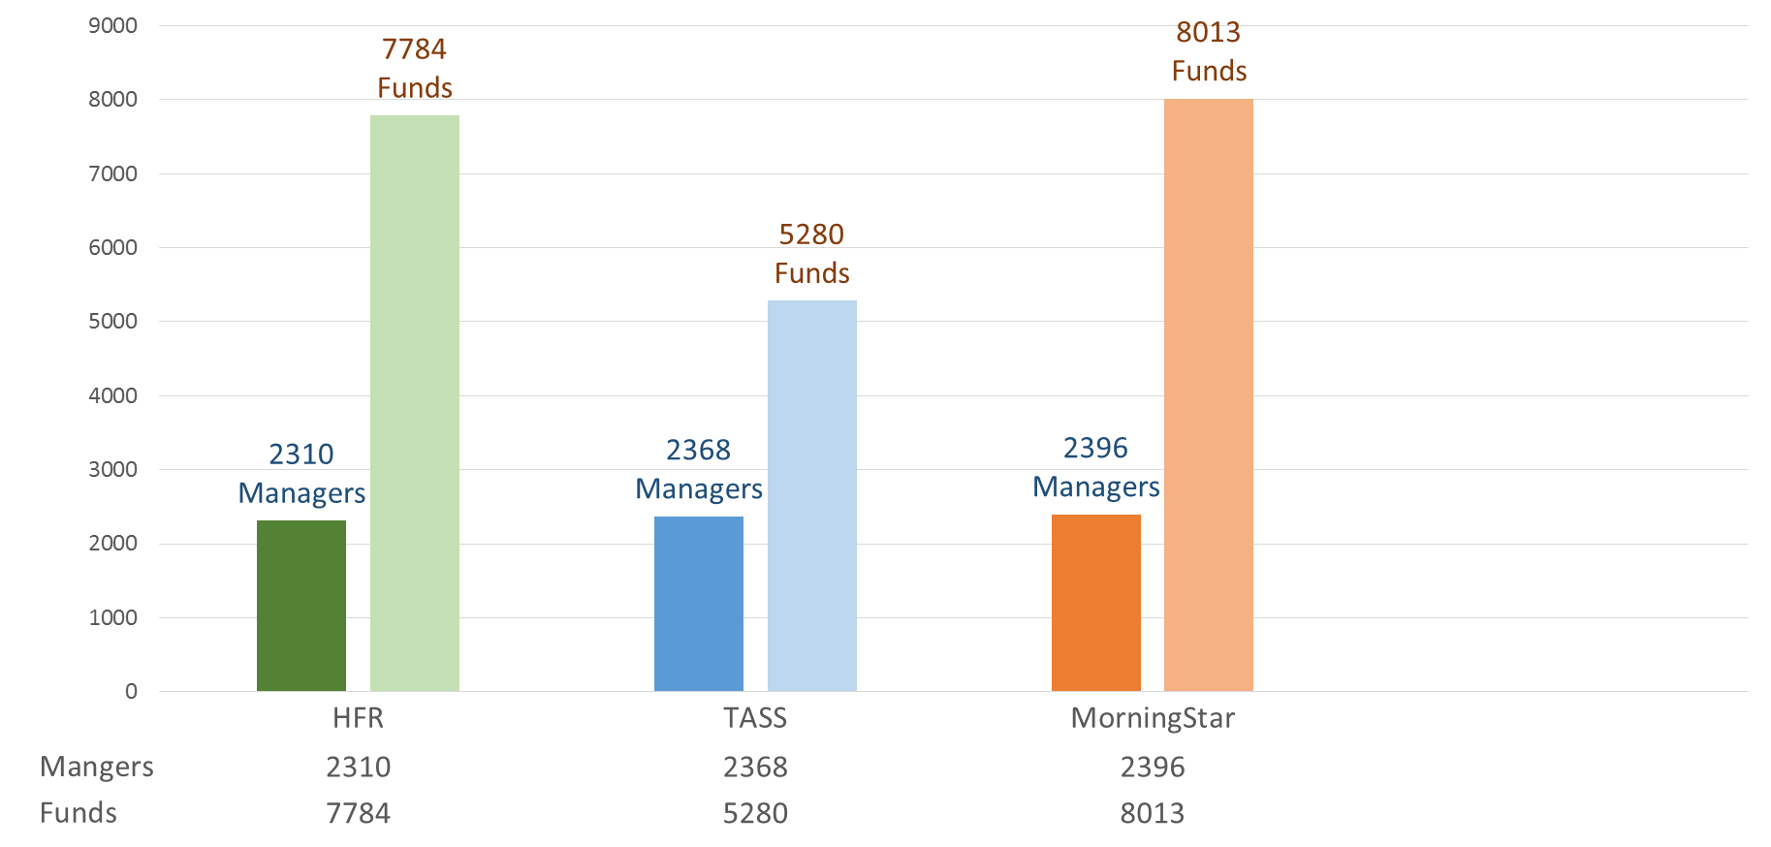

**Dead Funds**

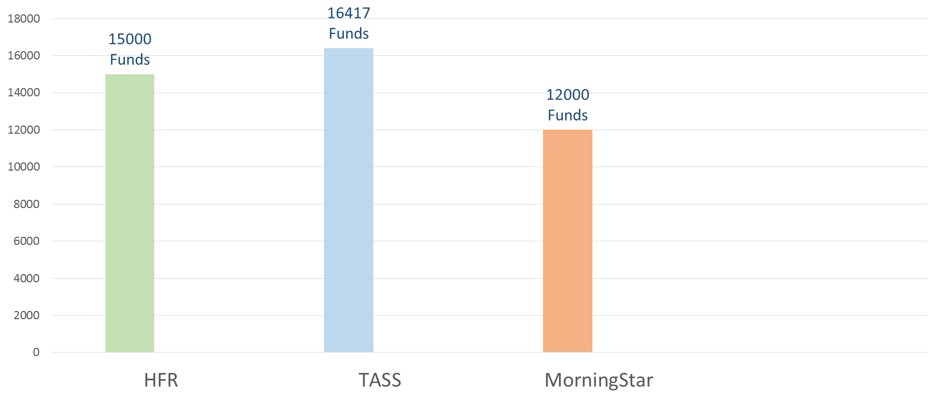

**Coverage of existing managers**

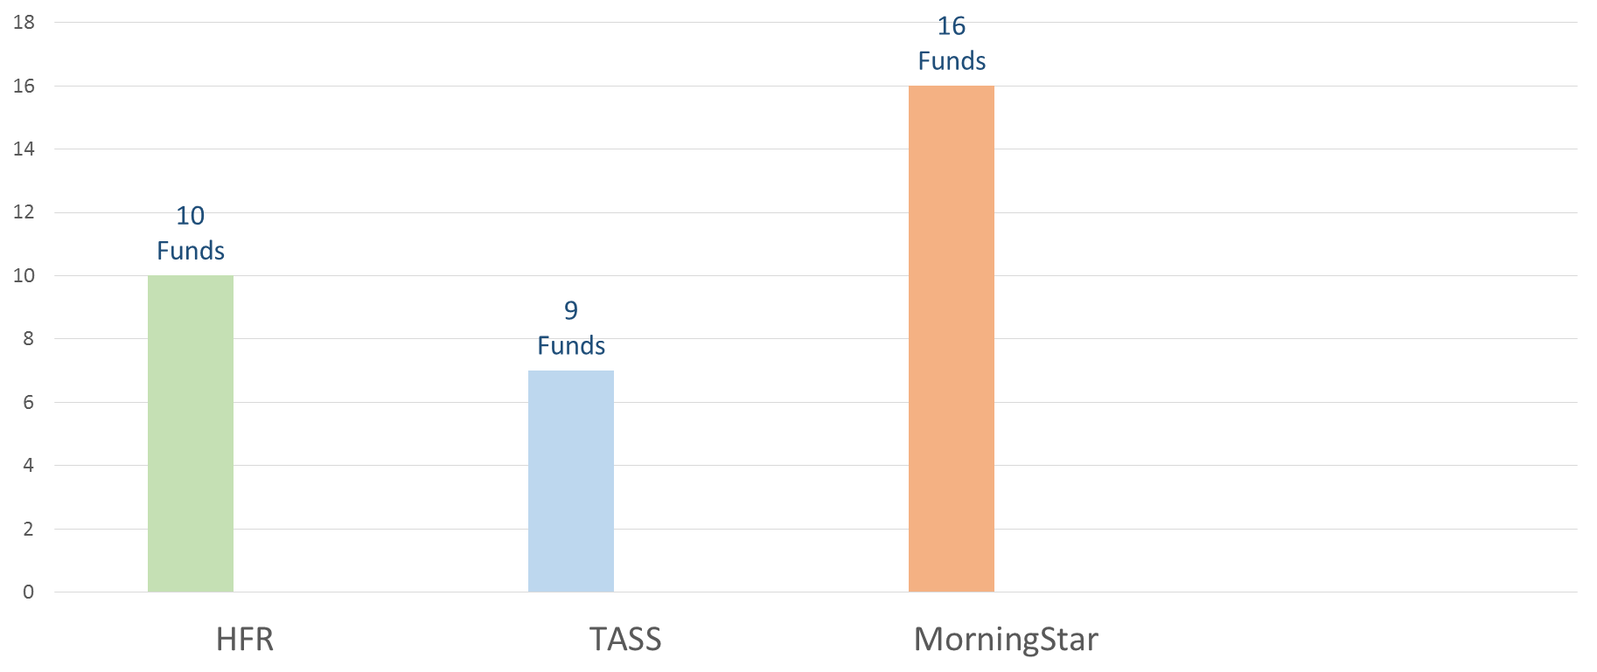

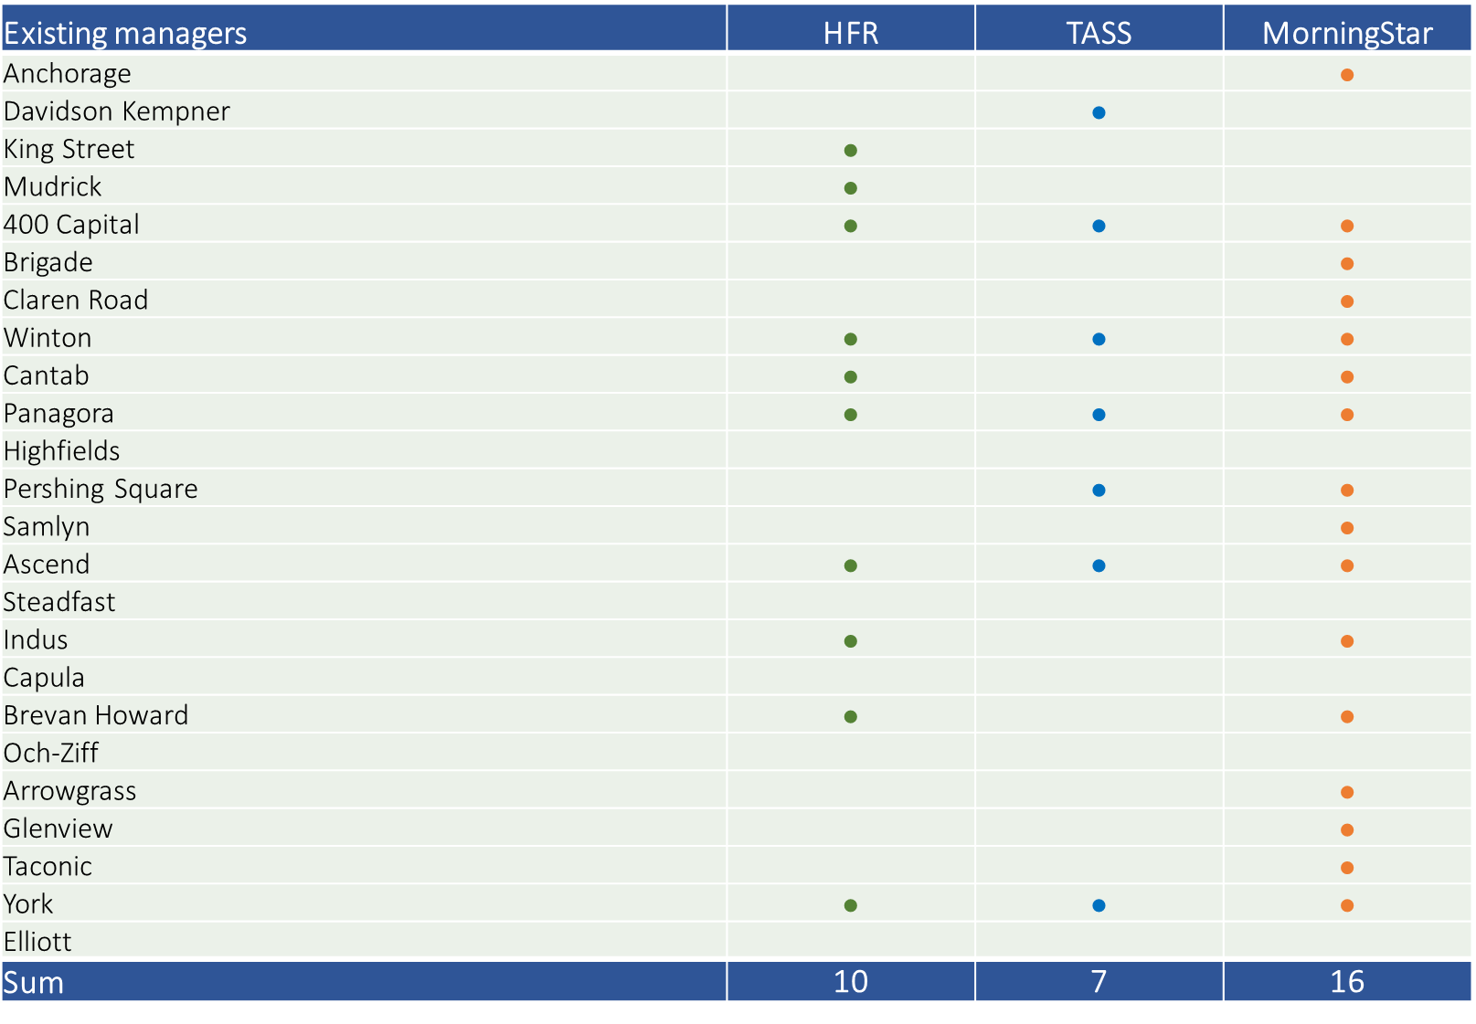

**Managers Overlap**

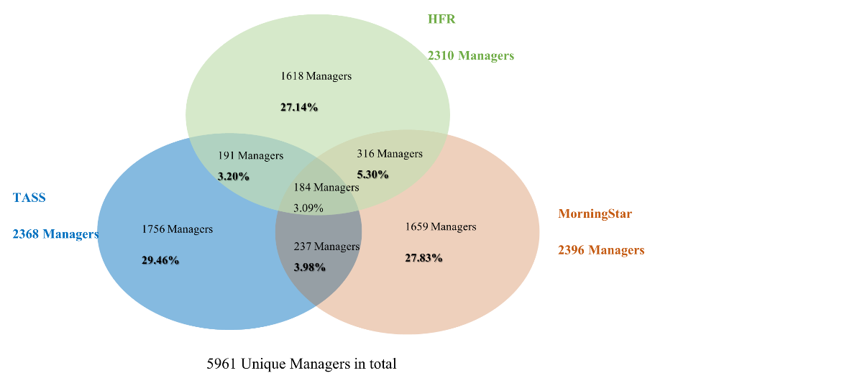

**Pricing**

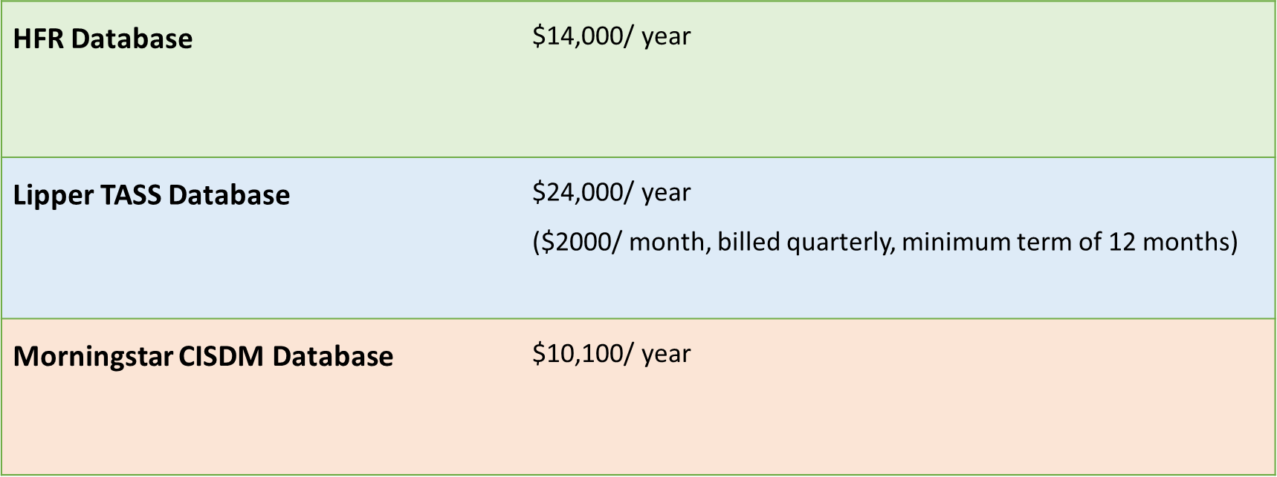

**AUM distribution**

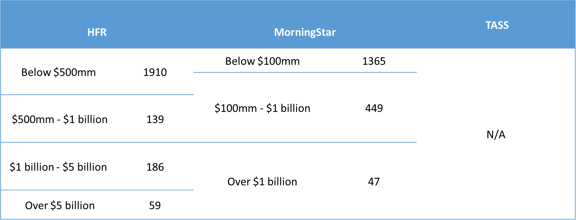

**Strategies distribution**

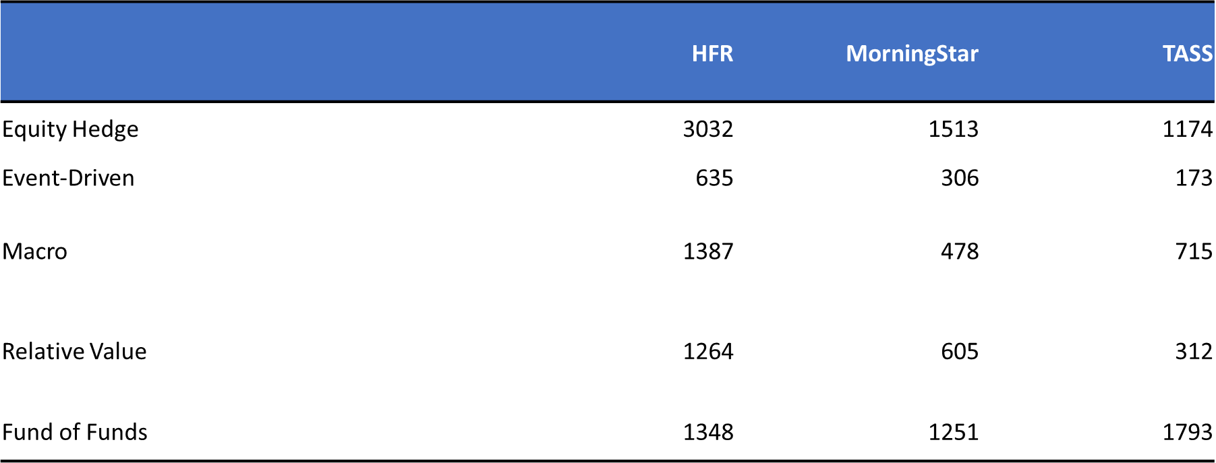

**Region distribution**

